[Home Stay]



A

[Humancomputerinterface] Course Project Report

in partial fulfilment of the degree

**Bachelor of Technology**

in

**Computer Science & Engineering**

**By**

SRAVANI ANUMALA 2303A510G7 (HOME STAY)

1. ANUSHA 2303A510H6 (HOME STAY)

Under the guidance of

FAIZA IRAM

Designation

**Submitted to**

**School of Computer Science and Artificial Intelligence**





**DEPARTMENT OFCOMPUTERSCIENCE& ENGINEERING**

**CERTIFICATE**

This is to certify that the **Human Computer Interface- CourseProject**Reportentitled **“ HOME STAY_____”**isarecordofbonafideworkcarriedoutbythestudent’s SRAVANI ANUMALA , A.ANUSHA bearingRollNo(s):2303A510G7, 2303A510H6 duringtheacademicyear2024-2025 in partial fulfillment oftheaward of thedegreeof ***BachelorofTechnology***in**ComputerScience&Engineering**bytheSR University,Warangal

**Lab In-charge Head ofthe Department**

**FAIZA IRAMDr. M. Sheshikala**

Ass. Professor Dept of CSE Assoc .professor &HOD(CSE)

SR University College, SR University College,

Ananthasagar, Warangal. Ananathasagar, Warangal

ACKNOWLEDGMENTs

**We owe an enormous debt of gratitude to our project guide Ms.FAIZA IRAM, Assistant Professor as well as Head of the CSE Department Dr. M. Sheshikala, Associate Professor for guiding us from the beginning through the end of the Project with their intellectual advices and insightful suggestions. We truly value their consistent feedback on our progress, which was always constructive and encouraging and ultimately drove us to the right direction.**

**We wish to take this opportunity to express our sincere gratitude and deep sense of respect to our beloved Vice Chancellor, Prof. Deepak Garg, for his continuous support and guidance to complete this project in the institute.**

**Finally, we express our thanks to all the teaching and non-teaching staff of the department for their suggestions and timely support. NT**

TABLE OF CONTENT

|  |  |
| --- | --- |
| TOPIC | PAGE NO |
| Abstract | 5 |
| Objective | 6 |
| Existing System | 7 |
| Proposed System | 8 |
| Software and Hardware requirements | 9 |
| Elements used in the project | 10 |
| Implementation | 11-16 |
| Design | 17– 19 |
| Conclusion | 20 |

ABSTRACT

This website offers a delightful and interactive platform for customers to explore and book a variety of homestay options, including Cozy Cottages, Luxury Villas, and Beachfront Apartments, with clear pricing per night. Featuring an elegant design, a user-friendly interface, and responsive functionality, the site allows visitors to select their preferred homestay, customize their booking by dates and number of guests, and calculate the total cost seamlessly. The booking process is supported by an intuitive modal window, enhancing user engagement. Additional features include contact information, a visually appealing gallery, and hover effects for an enjoyable browsing experience. Perfect for vacations or weekend getaways, the site ensures convenience and satisfaction for every traveler.

OBJECTIVE

1. **Simplify Booking Process**: Provide an easy-to-use platform for customers to browse, select, and book homestays online.
2. **Enhance User Experience**: Offer a visually appealing and interactive interface for seamless navigation and engagement.
3. **Customization Options**: Allow customers to customize their booking by selecting room type, dates, and additional amenities.
4. **Transparent Pricing**: Display clear and upfront pricing to help customers make informed decisions.
5. **Convenient Contact Information**: Ensure easy access to contact details for inquiries or assistance.
6. **Accommodate Every Occasion**: Cater to various events like vacations, family gatherings, and business trips with suitable accommodation options.

**EXISTING SYSTEM**

1. **Online Hotel Booking Websites**: Many hotels have their own websites where customers can browse rooms, check availability, and make reservations. Examples include Marriott and Hyatt.
2. **E-Commerce Travel Platforms**: Platforms like Booking.com and Expedia offer a wide range of accommodations, allowing customers to book homestays, hotels, and vacation rentals alongside flights and other travel services.
3. **Travel and Hospitality Apps**: Apps like Airbnb, MakeMyTrip, and Agoda partner with homestays, hotels, and vacation rentals to provide booking services directly through their platforms.
4. **Custom Homestay Platforms**: Websites like Vrbo and HomeAway specialize in vacation homes and homestays, offering options for personalization, such as choosing specific amenities and experiences.
5. **Local Homestay Listings**: Platforms like TripAdvisor and Google My Business list local homestays and hotels, allowing customers to view options and contact property owners directly for bookings.

These systems often include features like reviews, ratings, and booking tracking to enhance the user experience. The website **Book Your Homestay** aims to provide a more focused and personalized experience for homestay booking.

**PROPOSED SYSTEM**

1. **User-Friendly Platform**: A dedicated website designed specifically for booking homestays, offering a simple and intuitive interface.
2. **Interactive Property Gallery**: Customers can browse through a visually appealing collection of homestays with clear pricing, descriptions, and amenities.
3. **Customization Options**: The system allows users to personalize their bookings by selecting room type, check-in/check-out dates, and additional services such as meals or transportation.
4. **Dynamic Pricing Calculator**: Automatically calculates the total price based on selected dates, number of guests, and additional services, providing transparency in cost.
5. **Streamlined Booking Process**: A quick and straightforward reservation process with instant confirmation notifications and booking details.
6. **Mobile Compatibility**: Fully responsive design for easy access on smartphones, tablets, and desktops, allowing users to book accommodations on the go.
7. **Enhanced Engagement Features**: Hover effects, animations, and modal pop-ups to make browsing and booking more interactive and enjoyable.
8. **Centralized Contact Information**: Direct links for email and phone support, along with location details, to ensure customers can easily reach out for assistance or inquiries.

SOFTWARE REQUIREMENTS:

REQUIREMENTS

>>>> HTML

>>>>CSS

>>>>JAVASCRIPT

HARDWARE REQUIREMENTS:

1. **Server Requirements**:
   * High-performance web server (e.g., AWS, Google Cloud, or a dedicated server) with at least:
     + Processor: Quad-Core or higher (e.g., Intel Xeon, AMD EPYC).
     + RAM: Minimum 8 GB (16 GB recommended for scalability).
     + Storage: 500 GB SSD for faster read/write operations.
2. **Client Requirements**:
   * For end-users, devices like desktops, laptops, tablets, or smartphones with:
     + Modern web browsers (Chrome, Firefox, Edge, Safari).
     + Minimum 2 GB RAM and 16 GB storage for smooth browsing.
     + Internet speed of at least 10 Mbps for an optimal experience.
3. **Networking & Load Balancing**:
   * Reliable high-speed internet connection for the server (1 Gbps or higher).
   * Load balancer for distributing traffic evenly to prevent downtime during high traffic periods.

ELEMENTS USED IN THE PROJECT:

1. **HTML**:
   * Structure of the website, including headings, paragraphs, images, forms, and buttons.
   * Elements such as <header>, <main>, <footer>, <div>, and <form> create the basic layout.
2. **CSS**:
   * **Styling**: Defines the website’s visual appearance, including fonts, colors, spacing, and hover effects.
   * **Flexbox**: Used for responsive layout, ensuring the cake gallery adapts well to different screen sizes.
   * **Animations**: Includes effects like image scaling on hover and modal fade-in for an engaging user experience.
   * **Media Queries**: Enables responsiveness across various devices.
3. **JavaScript**:
   * **Dynamic Functionality**: Handles interactive features like opening and closing modals, updating total prices based on input, and triggering alerts for order confirmation.
   * **Event Listeners**: Used for detecting user actions such as clicking on cakes, selecting options, or changing input values.
4. **Images**:
   * High-quality images of cakes to create an appealing visual gallery.
5. **Forms**:
   * Collect user inputs for cake weight, occasion, and confirmation details.
   * Includes validation to ensure the inputs are correct (e.g., positive weight).
6. **Modal**:
   * Pop-up window for a focused and streamlined ordering experience.
7. **Buttons**:
   * Used for navigation and actions, such as placing an order or closing the modal.
8. **Contact Links**:
   * Hyperlinks for email and phone, allowing easy customer communication.
9. **Icons/Visual Cues**:
   * Close button (&times;) for modals and hover effects to enhance usability and navigation.
10. **Responsive Design**:

* Ensures that the website is accessible and functional on desktops, tablets, and mobile devices.

This combination of elements ensures the project is functional, visually appealing, and user-friendly

IMPLEMENTATION:

CODE:

<!DOCTYPE html>

<html lang="en">

<head>

<meta charset="UTF-8">

<meta name="viewport" content="width=device-width, initial-scale=1.0">

<title>Book Your Homestay</title>

<style>

        body {

            font-family: Arial, sans-serif;

            margin: 0;

            padding: 0;

            background-color: #f8f8f8;

        }

        header {

            text-align: center;

            padding: 20px;

            background-color: #ffcccb;

        }

        .property-gallery {

            display: flex;

            justify-content: center;

            flex-wrap: wrap;

            gap: 20px;

            margin: 20px;

        }

        .property-item {

            text-align: center;

            cursor: pointer;

        }

        .property-item img {

            border-radius: 10px;

            box-shadow: 0 4px 8px rgba(0, 0, 0, 0.2);

            transition: transform 0.2s ease-in-out;

        }

        .property-item img:hover {

            transform: scale(1.1);

        }

        footer {

            text-align: center;

            padding: 10px;

            background-color: #ffcccb;

            margin-top: 20px;

            font-size: 14px;

        }

        footer a {

            color: #ff4500;

            text-decoration: none;

        }

        footer a:hover {

            text-decoration: underline;

        }

        .modal {

            position: fixed;

            top: 0;

            left: 0;

            width: 100%;

            height: 100%;

            background-color: rgba(0, 0, 0, 0.7);

            display: flex;

            justify-content: center;

            align-items: center;

            display: none;

        }

        .modal-content {

            background-color: #fff;

            padding: 20px;

            border-radius: 10px;

            text-align: center;

            max-width: 400px;

            width: 80%;

            animation: fadeIn 0.3s;

        }

        .close-btn {

            font-size: 20px;

            color: red;

            float: right;

            cursor: pointer;

        }

        @keyframes fadeIn {

            from {

                opacity: 0;

            }

            to {

                opacity: 1;

            }

        }

        .form-group {

            margin: 10px 0;

        }

        select, input[type="number"] {

            padding: 5px;

            width: 100%;

            margin: 5px 0;

        }

        button {

            background-color: #ff4500;

            color: white;

            padding: 10px;

            border: none;

            border-radius: 5px;

            cursor: pointer;

            transition: background-color 0.3s;

        }

button:hover {

            background-color: #ff6347;

        }

</style>

</head>

<body>

<header>

<h1>Book Your Homestay</h1>

<p>Click on a property to make a booking!</p>

</header>

<main>

<div class="property-gallery">

<div class="property-item" onclick="bookProperty('Mountain View Homestay', 3000)">

<img src="https://example.com/mountain-view.jpg" alt="Mountain View Homestay">

<p>Mountain View Homestay - ₹3000/night</p>

</div>

<div class="property-item" onclick="bookProperty('Beachside Homestay', 5000)">

<img src="https://example.com/beachside.jpg" alt="Beachside Homestay">

<p>Beachside Homestay - ₹5000/night</p>

</div>

<div class="property-item" onclick="bookProperty('Forest Retreat Homestay', 4000)">

<img src="https://example.com/forest-retreat.jpg" alt="Forest Retreat Homestay">

<p>Forest Retreat Homestay - ₹4000/night</p>

</div>

</div>

</main>

<footer>

<p>Thank you for choosing our homestays!</p>

<p>Contact us at:</p>

<p>Email: <a href="mailto:home stay@villas.com">home stay@villas.com</a> | Phone: <a href="tel:+1234567890">+91 1234567890</a></p>

<p>Visit us: 123 Traveler's Lane, Homestay City</p>

</footer>

<div id="booking-modal" class="modal" role="dialog">

<div class="modal-content">

<span class="close-btn" onclick="closeModal()">&times;</span>

<h2 id="property-title"></h2>

<form id="booking-form">

<div class="form-group">

<label for="nights">Select Number of Nights:</label>

<input type="number" id="nights" name="nights" min="1" value="1" required>

</div>

<div class="form-group">

<label for="guests">Number of Guests:</label>

<select id="guests" name="guests" required>

<option value="1">1 Guest</option>

<option value="2">2 Guests</option>

<option value="3">3 Guests</option>

<option value="4">4 Guests</option>

</select>

</div>

<div class="form-group">

<p>Total Price: ₹<span id="total-price"></span></p>

</div>

<button type="button" onclick="confirmBooking()">Confirm Booking</button>

</form>

</div>

</div>

<script>

        let selectedPrice = 0;

        function bookProperty(propertyName, pricePerNight) {

selectedPrice = pricePerNight;

document.getElementById("property-title").innerText = `Book ${propertyName}`;

updateTotalPrice();

document.getElementById("booking-modal").style.display = "flex";

        }

        function closeModal() {

document.getElementById("booking-modal").style.display = "none";

        }

        function updateTotalPrice() {

            const nights = parseFloat(document.getElementById("nights").value);

            const totalPrice = nights * selectedPrice;

document.getElementById("total-price").innerText = totalPrice.toFixed(2);

        }

document.getElementById("nights").addEventListener("input", updateTotalPrice);

        function confirmBooking() {

            const nights = parseFloat(document.getElementById("nights").value);

            const guests = document.getElementById("guests").value;

            if (nights <= 0) {

                alert("Please select a valid number of nights!");

                return;

            }

            alert(`Your booking has been confirmed!\nProperty: ${document.getElementById("property-title").innerText}\nNights: ${nights}\nGuests: ${guests}\nTotal Price: ₹${document.getElementById("total-price").innerText}`);

closeModal();

        }

</script>

</body>

</html>

DESIGNS:

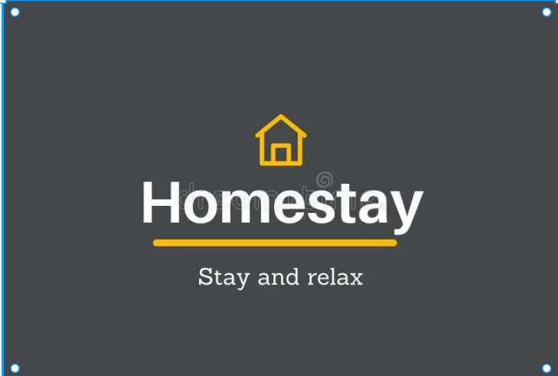

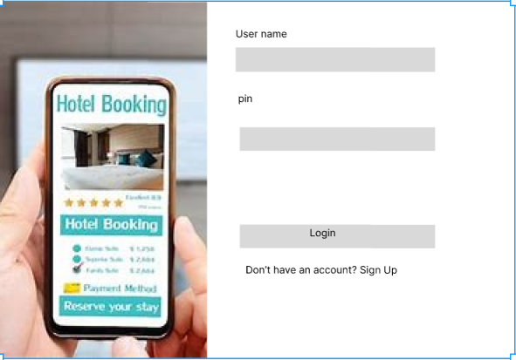

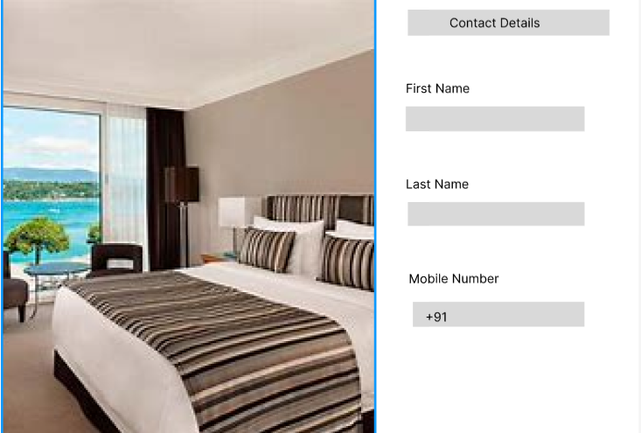

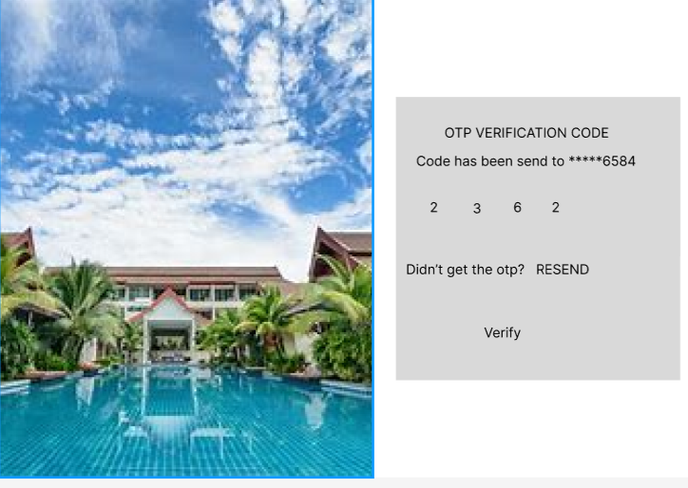

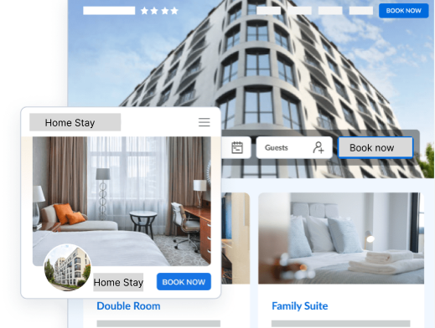

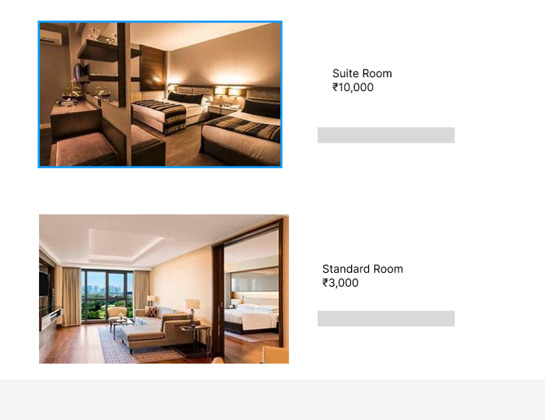

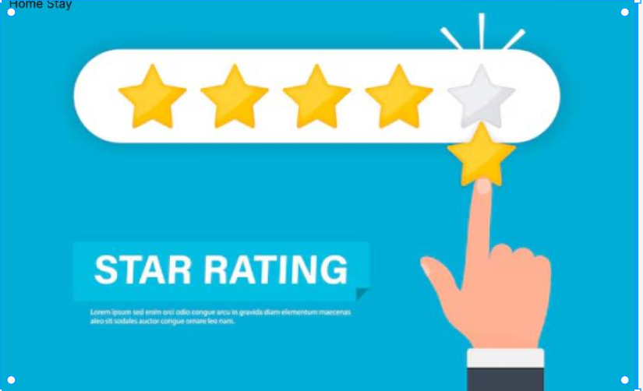

**CONCLUSION:**

The **Home Stay Hotel Management System** is designed to transform the way guests browse, book, and customize their stay online. It addresses common challenges in traditional hotel booking, such as limited room customization, lack of pricing transparency, and a complex booking process. With its user-friendly and visually appealing interface, the platform ensures a seamless and enjoyable experience for guests of all backgrounds and technical skill levels.

Key features include an **interactive room gallery**, a **dynamic pricing calculator**, and **personalized booking options**. Guests can effortlessly select their preferred room type, duration of stay, and special requests like meals or additional amenities. The system offers clear and upfront pricing, ensuring that guests understand the costs before booking, and allows for an easy and secure booking process with immediate confirmation.

The website is fully responsive and mobile-friendly, ensuring that guests can book their stays from anywhere, at any time. The platform is designed to make the process convenient and straightforward for travelers. Additionally, it provides centralized contact information for quick customer support, and engaging design features such as animations and hover effects create an enjoyable and interactive browsing experience.

By combining simplicity, customization, and convenience, the **Home Stay Hotel Management System** becomes the ideal solution for travelers seeking accommodation for vacations, business trips, or weekend getaways. It not only meets guest needs efficiently but also establishes itself as a reliable platform for booking stays, ensuring guest satisfaction with every reservation.